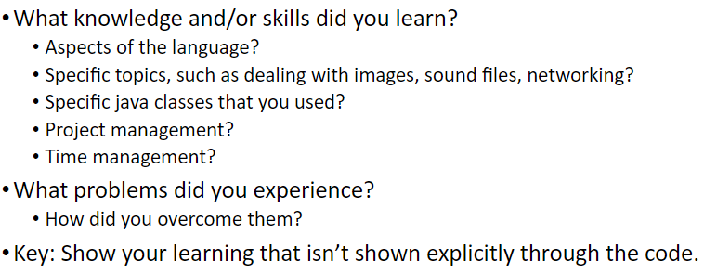

**Knowledge learning**: While we didn’t get far enough into the project to learn many new things about the language or things like graphics, it was definitely a nice wrap-up of some of the skills we had learned throughout the semester. I tried getting an image to display but that was about the extent of our visual aspect. In the code to display the image, there were multiple packages inputted but in all honesty, I didn’t understand what they mean but simply that they were needed to display the image. I got it (!!) but I ran out of time to implement it into the main program such that the customer can input “menu” and then have the image show up.

**Time management improvements**: This project did kind of emphasize my need to improve my time management skills… I was pretty on track in the beginning but towards the end as different class workloads built up and schedule changes were made due to the power outages I ran out of time to keep working on this project. However, I honestly think I need to stop using other course workloads as an excuse because it does still get worse from here and I think that other schools and more prestigious programs have it worse :((. Basically, I should probably re-evaluate my time management strategies (I usually like blocking things off and doing one thing at a time instead of multiple a little per day which was probably the downfall here).

**Struggles:** We struggled a bit with hard coding as the menu items and their prices would not be able to change and be modified. This was partially solved soon after when we made a text file of the items and their prices, and the program could read the prices that matched the designated menu item. However, this still meant that the menu items themselves are still hardcoded and only the prices are modifiable. While this is a step in the right direction, being able to edit the menu text file and add menu items should be the next step in improving the program.